UNITY BLAZE CERTIFIED PARTNER
Social Media Toolkit

MESSAGE #1 - We are a Certified Unity Blaze Partner committed to making the outdoors more inviting and welcoming for all.

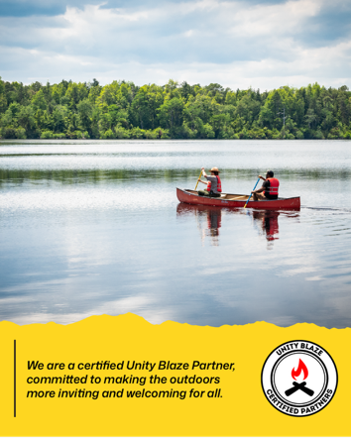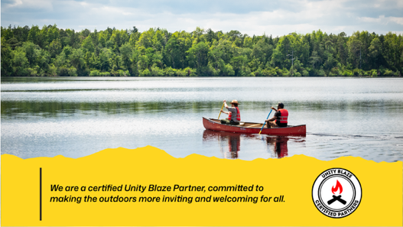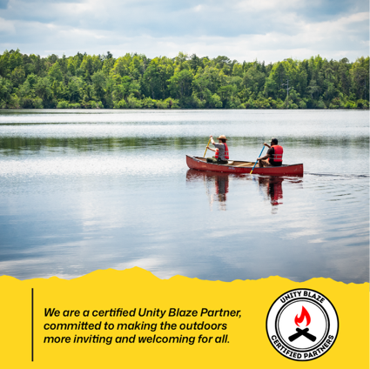
Instagram: 4:5
Twitter/X: 16:9
LinkedIn/Facebook: 1:1

Outdoor Retailers

➡ 🌟 We are a Certified Unity Blaze Partner, creating an outdoor community where everyone feels welcome. Together, we’re lighting the way for connection and belonging. #UnityBlaze

Campgrounds
➡ 🏕️ As a Certified Unity Blaze Partner, we’re dedicated to ensuring our campgrounds are spaces where everyone feels at home. Join us as we blaze new trails in outdoor hospitality. #UnityBlaze

State Parks/DNR
➡ 🌲 We’re proud to be a Certified Unity Blaze Partner, working to ensure everyone feels a sense of belonging in our parks and public lands. Let’s explore, connect, and grow—together. #UnityBlaze

RV Partners
➡ 🚐 Adventure is for everyone! As a Certified Unity Blaze Partner, we’re making the RV lifestyle more welcoming so that every traveler feels at home on the road. #UnityBlaze

Outfitters/Guides

➡ ⛺ Adventure knows no boundaries! As a Certified Unity Blaze Partner, we’re here to guide every explorer toward a warm and welcoming outdoor experience. Let’s blaze the trail together. #UnityBlaze

Industry Manufacturers
➡ 🛠️ Everyone deserves gear that supports their journey. As a Certified Unity Blaze Partner, we proudly create products that support a welcoming and diverse outdoor experience. #UnityBlaze

Land Conservancies/Trusts
➡ 🌍 Protecting land is only part of our mission. As a Certified Unity Blaze Partner, we work to ensure these spaces are open, welcoming, and meaningful for all. #UnityBlaze

Tourism Development Authorities
➡ ✈️ We’re proud to be a Certified Unity Blaze Partner, inviting all to explore our destination with open arms. Together, we’re creating a travel experience where everyone belongs. #UnityBlaze

MESSAGE #2 - We are all part of the Outdoor Community
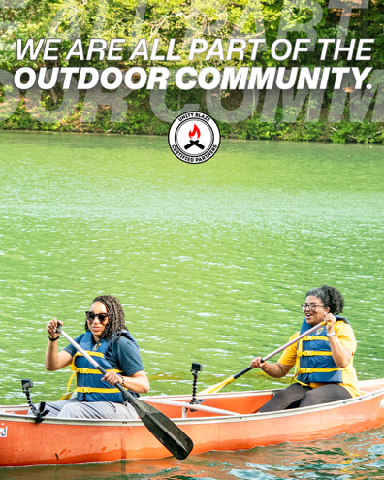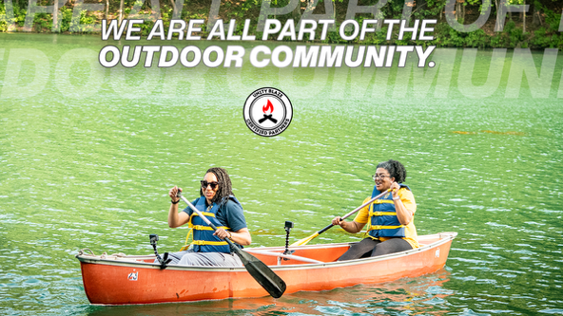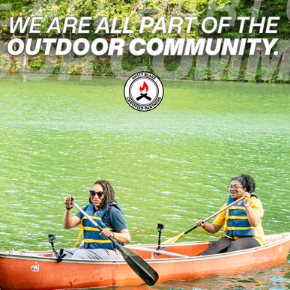
LinkedIn/FaceBook: 1:1
Twitter/X: 16:9
Instagram: 4:5

Outdoor Retailers
➡ 🌟 The outdoors is for everyone, and so are we. We are all part of the Outdoor Community—let’s keep building a culture of welcome and connection for every adventurer. #UnityBlaze

Campgrounds
➡ 🏕️ No matter who you are or where you’re from, the outdoors is for you. We are all part of the Outdoor Community, and we’re here to help you feel right at home under the stars. #UnityBlaze

State Parks/DNR
➡ 🌲 We are all part of the Outdoor Community, and that means everyone has a place in nature. Come explore, connect, and belong in the great outdoors. #UnityBlaze

RV Partners
➡ 🚐 Wherever the road takes you, you belong. We are all part of the Outdoor Community—and every traveler deserves to feel welcome along the journey. #UnityBlaze

Outfitters/Guides
➡ ⛺ We believe adventure is for everyone. As part of the Outdoor Community, we’re proud to guide people toward experiences that bring us together. #UnityBlaze

Land Conservancies/Trusts
➡ 🌍 Protecting the outdoors means ensuring everyone feels a connection to the land. We are all part of the Outdoor Community—and these lands are for all of us. #UnityBlaze

Tourism Development Authorities
➡ ✈️ From mountains to beaches, we are all part of the Outdoor Community. Our destination is for everyone—join us in celebrating the power of shared outdoor experiences. #UnityBlaze

MESSAGE #3 - You are INVITED and WELCOMED

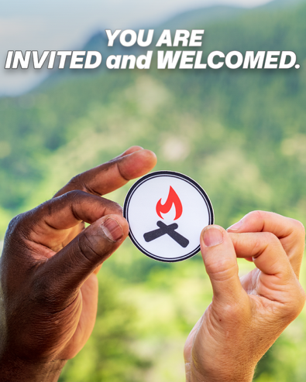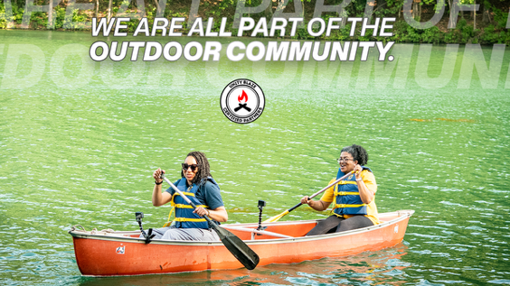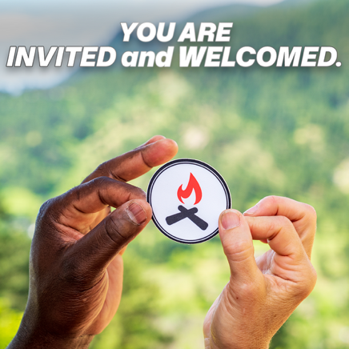
LinkedIn: 1:1
Twitter/X: 16:9
Instagram: 4:5

Outdoor Retailers
➡ 🌟 No matter where you’re from or what your adventure looks like, you are INVITED and WELCOMED. Let’s make the outdoors a space everyone can enjoy. #UnityBlaze

Campgrounds
➡ 🏕️ Every camper deserves to feel at home under the stars. You are INVITED and WELCOMED to enjoy a stay where you truly belong. #UnityBlaze

State Parks/DNR
➡ 🌲 Nature is calling, and you are INVITED and WELCOMED. Come experience the beauty of the outdoors in a place where you belong. #UnityBlaze

RV Partners
➡ 🚐 Adventure is for everyone! You are INVITED and WELCOMED to join us on the road to new destinations and meaningful outdoor moments. #UnityBlaze

Industry Manufacturers
➡ 🛠️ The outdoors is for everyone, and so is the gear we create. You are INVITED and WELCOMED to be part of a community that values every adventurer. #UnityBlaze

Outfitters/Guides
➡ ⛺ Adventure awaits, and you are INVITED and WELCOMED to join us. Let’s create unforgettable experiences, together. #UnityBlaze

Land Conservancies/Trusts
➡ 🌍 These lands are for everyone, and so is the experience of enjoying them. You are INVITED and WELCOMED to connect with nature in ways that matter. #UnityBlaze

Tourism Development Authorities
➡ ✈️ Whether you’re a first-time explorer or a seasoned adventurer, you are INVITED and WELCOMED to discover all our destination has to offer. #UnityBlaze

